Basic income, climate change, and the future of work
BIEN Congress
University of Queensland, Brisbane, Australia, 9/28/2022

Michael W. Howard
Department of Philosophy
University of Maine, USA
mhoward@maine.edu

This paper is part of a larger project addressing the role of basic income in response to the challenge of climate change. The challenge of climate change is how to keep global temperature from rising beyond 1.5—2 degrees C above preindustrial levels, without locking hundreds of millions of people in extreme poverty, and without imposing painful austerity on the most vulnerable in wealthier countries.
This is a matter of justice, but also of political feasibility. If we do not give what is due to the least advantaged both globally and nationally, we will fail to respond adequately to the challenge of climate change.
More specifically this paper is a response to a question about the compatibility of work time reduction (WTR) and global justice obligations, posed by Philippe Van Parijs at the presentation I made for a conference at the Catholic University of Louvain in February of 2022. Before turning to his question, I will summarize what I argued in that talk.
I claimed that basic income in response to climate change involves 2 policies. First, it involves carbon pricing and dividends. Carbon pricing will drive fossil fuels out of the market and incentivize the shift to renewable energy. Dividends will rectify the injustice of a regressive consumption tax, give people an immediate reward for moving away from fossil fuels, and make steadily rising carbon prices politically feasible. The dividends will constitute a partial basic income comparable in size to the Alaska Permanent Fund Dividend. Second, assuming that carbon pricing alone is not sufficient to bring about the required carbon emissions reductions, and, that it will be necessary to reduce energy demand, an ecological basic income closer to a full basic income is a desirable policy to support worktime reduction and work sharing. If carbon pricing had been introduced 30 years ago, it might have been sufficient to bring about a transition away from fossil fuels that stayed within the 1.5--2 degrees Celsius temperature rise. But given the small window we have to stay within that limit, carbon pricing must be complemented by substantial government investments, international cash transfers, and limitations on consumption that sometimes are described as degrowth. Degrowth, or slower growth, presents another challenge. Other things equal, an economy that stops growing will face rising unemployment. The old strategy for creating employment and distributing income--growth plus investment in jobs--has been faltering for years and collides with environmental limits to growth, notably global warming, but also other forms of ecological overreach. The new strategy will involve less reliance on growth add more reliance on redistribution, in particular, a basic income to bring about distributive justice and robust climate change policy.
The question that Van Parijs put to me was, should we really be calling for less work, and spending more of our time living “la dolce vita”? Or, should we be calling for less consumption in the global North, but continued work effort? He has elaborated this question in a recent paper:
“Consuming less in the global North does not mean producing less in the global North, because production in the North must help fund consumption in the South. Anyone who spent any time in less developed countries realizes that it is simply unacceptable for us living in the North to go and tell people in the South: “Sorry, but for the good of our planet, you will have to keep your level of private consumption, public services and infrastructure at a level far lower than the one we have been enjoying for decades.” Moreover, even under the most optimistic assumptions, we cannot expect development policies and transnational migration to bring down the level of global inequality to an acceptable level. Consequently, there is no realistic scenario for global justice that can dispense with massive financial transfers from the North to the South.”
I agree with this assessment. To elaborate, note that North America and Europe are responsible for nearly half of historical greenhouse gas emissions, leaving very little for the rest of the world in the carbon budget for 1.5 degrees Celsius or 2 degrees Celsius temperature rise.
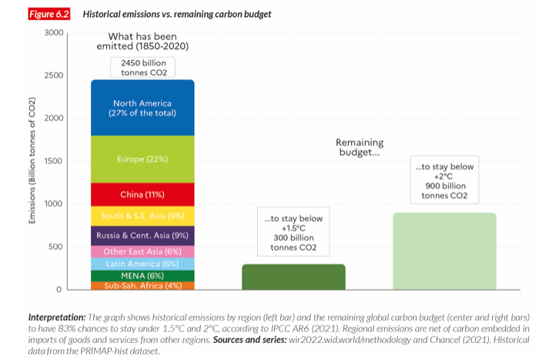
As Chancel et al. (2022) remind us, “According to the latest IPCC report, there are 300 billion tonnes of CO2 left to be emitted if we are to stay below 1.5°C (with an 83% confidence rating) and 900 billion tonnes of CO2 left to stay below 2°C (with the same level of confidence). At current global emissions rates, the 1.5°C budget will be depleted in six years and 2°C budget in 18 years.”
The carbon budget for an 83 percent chance of staying below 1.5C, if allocated from 2021-2050, amounts to 1.1 tonnes per capita of CO2e per capita globally (and 3.4 tonnes to stay below 2C). Current global emissions are currently 6.6 per capita annually, with wide variation across countries and regions:
North America 20.8
Europe 9.7
East Asia 8.6
Sub-Saharan Africa 1.6
What would be a fair share of the remaining 1.5C carbon budget over the next 30 years? Peter Singer has proposed allocating equal per capita shares, which would allow each person 1.1 tons of CO2 emissions annually. (For flexibility there could be some trading, and this would confer a significant financial advantage on developing countries.) But then even people in Sub-Saharan Africa would be expected to cut their carbon emissions from an already globally low level. Nevertheless, equal per capita shares would impose a very demanding emissions reduction obligation on wealthy countries. The US, for example, over the next 30 years would need to reduce emissions so that the average per capita emissions annually would be about 5 percent of current emissions, or else pay for equivalent emissions reductions elsewhere. This would entail rapid emissions reductions and massive cash transfers. Nonetheless this principle is not demanding enough.
The problems with the equal per capita shares principle are first, it ignores past pollution which has used up much of the total carbon budget and enriched countries in the global North. Second it ignores ability to pay, so countries still deep in poverty would have the same emissions reduction obligations as countries that have resources that allow them to enjoy considerable luxury. Therefore, too little room is left for development out of poverty, an injustice which developing countries simply will not accept. Because of that, affluent countries that ignore this injustice will fail to reach the global climate targets. Therefore, affluent countries must assume more responsibility than equal per capita shares, because of their past emissions and because of their ability to absorb the cost with minimal suffering.
This leads us to a combination of two principles: 1. Polluter pays (responsibility), and 2. Ability to pay (capacity).
These principles are in accord with the United Nations Framework Convention on Climate Change [UNFCCC] goal of GHG stabilization “on the basis of equity in accordance with their common but differentiated responsibilities and respective capacities”
These principles have been defended by Simon Caney and elaborated by Tom Athanasiou and others at EcoEquity. Using EcoEquity’s calculator, we find that the US, while emitting 14 percent of CO2 annually, should be responsible for 37 percent of global emissions when past emissions (since 1950) and ability to pay are taken into account. This means that, to stay below 1.5C (in this calculation with only a greater than or equal to 50% chance) the US must reduce carbon emissions 184 percent below 2005 levels by 2030. It is very difficult to reduce emissions below 100 percent, therefore much of the emissions reductions would need to occur elsewhere, but the cost of those reductions would be borne by the US. Using the same calculator and similar settings, US Fair Shares arrived at a goal of 195 percent reductions, split between 70 percent reductions of domestic emissions by 2030 and an international responsibility for the equivalent of 125 percent elsewhere.
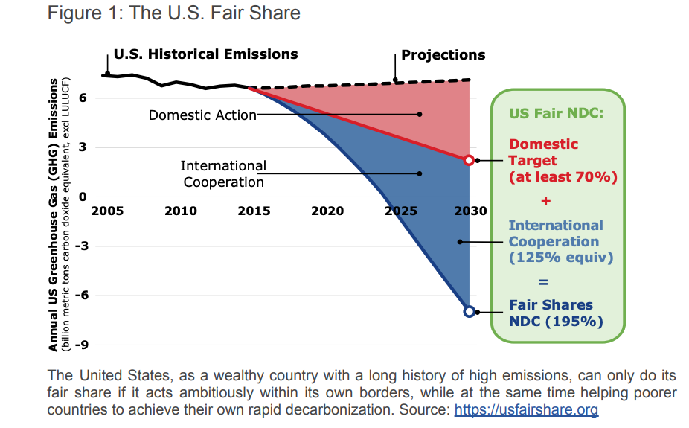
Using the same settings as for my US calculation, we find that India, although now producing 7 percent of annual global emissions, should be held responsible only for .14 percent because of its small share of historical emissions and the large number of people below the development threshold of $7500 annually. China falls in between, producing 27 percent of global emissions in 2019, but responsible for only 11 percent of emissions reductions because of a still large number of people in poverty, and a rising, but still relatively small share of historical emissions. Both India and China must reduce domestic emissions, but most of these reductions in India, and more than half in China, must be paid for by wealthier polluters with a greater share of historical emissions.
Meeting this global obligation will require large cash transfers from the United States and other wealthy countries. There is wide variation among the financial estimates of what is needed from the US for global mitigation, from a low of $57 billion annually to about $500 billion. A common estimate of the cost of climate change mitigation is 1.5 to 2% of gross world product which in 2021 was $94 trillion, i.e, $1.4—$1.9 tr. The US obligation, 37 percent of that, would be $518-700 bn annually. (Compare the 2022 Department of Defense budget of $715 bn). Assuming about half for cash transfers that would be $259-350bn annually. A thorough analysis by Stern and Stiglitz, using different estimates of the social cost of carbon, yields a range of estimates from $264 bn to 529 bn annually. USA Fair Shares, aiming for a very conservative estimate of US international obligations, assumes $57 bn for international mitigation annually, based on a very low social cost of carbon, but adds conservative estimates for adaptation, loss and damage, which the other estimates above all ignore, for a total of $160 bn annually.
Current practice falls far below even the most conservative of these estimates. The total of the Developed Countries Paris Pledge is $100 billion per year for 2020-2025, of which the US share, based on gross national income and cumulative emissions is $43-50 billion/ yr. The Obama Administration pledge was only $3 billion, with a first installment to the Green Climate Fund of $500 million (0.16%). The Biden Administration increased the pledge to $11.4 billion/yr by 2024 (4% of a fair share; 25% of a fair share of the Paris pledge). Only Bernie Sanders’ plan (2019), calling for $200 billion to the Green Climate Fund, to “reduce emissions among the less industrialized nations by 36% by 2030,” begins to approach what is needed.
Summing up thus far, the first difficulty for work time reduction is that it may undermine the ability of the United States to produce enough wealth to meet its global obligations for carbon emission reductions. A 2nd difficulty has to do with threats to productivity. As Van Parijs points out, restriction of fossil fuel use will, other things equal, result in a decrease in labor productivity, so more labor will be needed to produce the same amount of goods. (We are focusing on the threat to productivity from reduction in fossil fuel use, but there are other threats, such as we have experienced during the pandemic.) This entails that more labor will be needed to produce a given level of GDP out of which UBI is funded. So a decline in work effort, other things equal, will lead to a lower UBI, or threaten its viability altogether. And here is the problem for work time reduction:
“Faced with the prospect of falling productivity, therefore, we cannot nonchalantly respond that we shall work less and relax, contenting ourselves with a lower level of consumption. If we believe in global justice, the de-growth of Northern consumption should rather be combined with whatever additional efforts are needed to prevent falling productivity to show in falling production. Introducing an unconditional basic income, in this context, does not exactly seem the soundest thing to do.”
Van Parijs acknowledges a couple of mitigating factors:
  - Automation may more than compensate for productivity losses.
  - UBI may enhance productivity, functioning as ‘venture capital for the people’—if combined with lifelong learning and promotion of local communities.
But it is clear that the goal of UBI is to be compatible with, or even enhance, production, not to promote la dolce vita. Is it politically feasible to ask working people to work more but consume less? Van Parijs responds:
“The younger and future generations in the global North will need to content themselves with less material consumption than what our generation could get away with. To make this fact acceptable to them, indeed to make them embrace their future enthusiastically in spite of this fact, one needs to offer them a realistic utopia, on which hopes for a better life can credibly be hooked. This utopia must be consistent with both global justice and intergenerational justice yet able to outcompete the rival dystopias of neo-liberalism, xenophobic nationalism and religious fundamentalism. Even more than I did nearly forty years ago, I believe that the emancipatory idea of an unconditional basic income must feature at the core of such a realistic utopia.”
An emancipatory basic income must involve real freedom, the “power to say no” as Karl Widerquist puts it, the freedom to form your own communities for work and living. UBI must be high enough to make good on this promise. Is a UBI at the poverty line high enough? [In the US, the annual cost of such a UBI would be more than $500bn—not the gross cost but the net cost to net contributors (Widerquist, 2017)]. I will not attempt to answer this question here, but will only make two comments:
- Even a partial UBI can have some emancipatory effect. Alaska’s PFD had no overall effect on employment, and “increased part-time work by 1.8 percentage points”(Jones and Marinescu, 2018). It enabled some people to work less and others to work more, enhancing the freedom of both.
- Most will still seek work if the basic income is set at the poverty line, based on all the evidence from guaranteed income pilot programs. But the UBI could have profound effects on the ability of workers to form their own enterprises or cooperatives, or to bargain from a position of strength to gain a greater share of decision-making and productivity gains, and to take those productivity gains in free time rather than increased consumption.
Now, to return to Van Parijs’s question about worktime reduction, I want to make two points. First, work time reduction is compatible with sustaining overall work effort. If combined with work sharing it is possible to have fewer hours worked per person but the same overall hours worked when there are more people employed. And, if worktime reduction is achieved through productivity improvements there need not be any loss in production. Juliet Schor has shown how a four-day work week can be as productive as a five-day workweek because workers can be more efficient during those four days. And the four-day work week has many environmental, health, and social benefits connected with less commuting, better work-life balance, less consumption of fast food, and so on. I leave aside the question of whether work time reduction should be voluntary or mandatory. A UBI could facilitate or complement either.
The global transfers I mentioned earlier, [which, by the way, can include a small global BI, to a. reduce extreme poverty, and b. stimulate demand for necessities], can include subsidies for imports of green energy infrastructure, leading to demand for new employment directly serving the ends of global climate justice, even as work time per person is reduced.
My second point has to do with the distribution of wealth, income, and carbon emissions. Emissions reductions in the global North should not, and need not, fall on the most vulnerable there. An ecological BI need not be part of an austerity agenda. Below is a the widely used champagne glass illustration of the unequal distribution of global income. The richest 10 percent receive 52 percent of global income while the poorest 50 percent receive only 8 percent. (So unequal is the income between nations that the richest 10 percent includes 64 percent of the US population.) Wealth is even more unequally distributed than income, with the richest 10 percent owning 76 percent of the wealth, and the poorest 50 percent owning only 2 percent. Emissions tend to track income, with the top 10 percent of emitters being responsible for 48 percent of global emissions, and the bottom 50 percent only 12 percent.
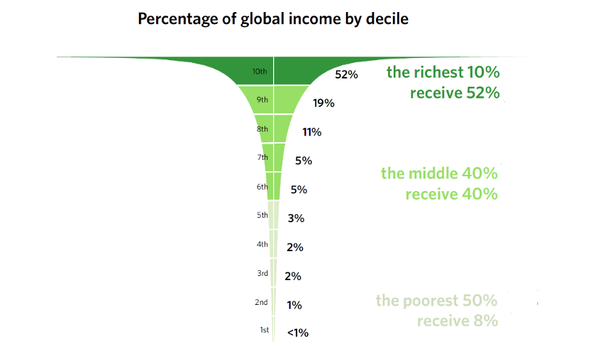
Invoking both the polluter pays principle and the ability to pay principle, we can conclude that the burden of emissions cuts by 2030 can and should fall on the more affluent. As Chancel et al. (2022) explain, “First, in rich countries, the bottom 50% is already below the 2030 per capita target [of 50% emissions reductions globally by 2030] …or very close to it…. It follows that all emissions reductions efforts are to be made by the top half of the distribution. In the US, the top 10% must cut its emissions by close to 90% in order to reach the 2030 per capita target, and the middle 40% by around 50%. The degree of efforts required … in France is similar. Second, it appears that in emerging countries, not all groups should increase their emissions levels. While the bottom and middle of the distribution are currently below the 2030 target, the top 10% is significantly above it. Indeed, in China, the top 10% must cut its emissions by more than 70% to meet the sustainable target. The value is also significant in India (-58%).”
How can these ambitious targets for emissions reductions by the wealthy be achieved? Chancel et al. argue that taxes should be shifted from consumption to assets. There is more choice available to asset owners, for example in deciding which companies to invest in, than there is to consumers, for example, in deciding how to heat their homes. They propose two taxes to support international climate mitigation:
- 1. ”10% tax rate on the value of carbon assets owned by global multimillionaires would generate at least $100bn in a year. This value is non-negligeable: it represents about 1.5 times the current estimated annual costs of adaptation to global warming in developing countries (about $70bn per year in 2020).” The tax would also discourage investment in carbon assets.
- 2. 1-3% progressive wealth tax on millionaires
“ It is estimated that 2% of GDP in additional annual investments are required (i.e. about $2,000bn). As a matter of fact, the very large additional investments in infrastructures required to meet the energy transition challenge needs considerable new sources of financing and these will hardly be met by taxes on highly polluting assets alone.”
A combination of these two taxes would raise revenue equal to 1.7% of global income, in the range of the 1.5-2% GWP often cited as the amount needed for mitigation.
Conclusions
Emissions reductions will require:
- Carbon pricing and dividends (therefore a partial UBI)
- Public investments in green alternatives
- Reduced consumption in wealthy countries
- Technology and Cash transfers to the global South
Reduced consumption with continued (green) production will require:
- A full UBI to support—more efficient, more freely chosen, more sustainable—work.
- Reduced consumption primarily by the upper 50%/10%--through wealth/asset taxes.
- WTR with work sharing, productivity gains, and continued overall work effort.
I close with a question: Will there be enough resources left, after costs of energy transition, for a full—and emancipatory—UBI? This is a difficult question to answer, given the uncertainty about the costs of energy transition, and about the size of an emancipatory UBI. But given the estimated cost of the US fair share of mitigation—not to mention adaptation, loss and damage—of $518—700 billion, and one estimate of the net cost of a UBI to the net contributors of $539 billion, and given the likely continued competition for public funds from other crises (health, geo-political), UBI advocates should not underestimate the political challenge posed by the twin costs of a UBI and a fair share of the climate change mitigation.
I am here only able to sketch a few directions for further research on this question. Thomas Piketty maintains that there is much room for raising marginal tax rates. A tax of 80 percent on incomes over $500,000 or $1 million, “would not reduce the growth of the US economy but would in fact distribute the fruits of growth more widely while imposing reasonable limits on economically useful (or even harmful) behavior.” However such a tax “would not bring the government much in the way of revenue, because it would quickly fulfill its objective: to drastically reduce remuneration at this level but without reducing the productivity of the US economy, so that pay would rise at lower levels….” To raise revenue for the “meager US social state…taxes would have to be raised on incomes lower in the distribution (for example… rates of 50 or 60 percent on incomes above $200,000).” Together with the wealth taxes proposed by Chancel, Piketty, et al., it does seem possible to fund both a UBI and robust climate mitigation, but only if these efforts are combined with an unabashedly egalitarian agenda. Research indicating the likely effects of some such scheme of taxes in conjunction with a basic income would be a valuable contribution to that egalitarian agenda.

See my paper for the 2019 BIEN Congress, “The Atmospheric Commons and Carbon Dividends: Implications for global and national basic income policies”, https://basicincome.org/wp-content/uploads/2020/01/BIEN_India_2019_Howard_The-Atmospheric-Commons-and-Carbon-Dividends.pdf This 2019 paper is an updated and shortened version of a paper presented at the BIEN 2018 Congress in Tampere, Finland. That paper is available here: https://basicincome.org/wpcontent/uploads/2018/09/Cosmopolitanism-and-an-ecological-basic-income.pdf Also relevant is the overlapping paper posted in the USBIG Discussion Paper series, presented at the NABIG Congress, Hamilton, Ontario, 2018: https://usbig.net/papers/(Howard)_The_Ecological_Case_for_Basic_Income_A_Challenge_for_Convergence.pdf and this paper: Howard, M., Pinto, J., & Schachtschneider, U. (2019). Ecological Effects of Basic Income. In The Palgrave International Handbook of Basic Income. Ed. Malcolm Torry. Palgrave Macmillan, 2019. https://www.palgrave.com/gp/book/9783030236137
See James Boyce, The Case for Carbon Dividends, Polity, 2019.
See P. Van Parijs and Y. Vanderborght, Basic Income, Harvard 2017, chapter 1.
“Climate Change and Covid-19 Pandemic: Crucial Pushes or Deadly Blows for Basic Income,” 2021 https://alfresco.uclouvain.be/alfresco/service/guest/streamDownload/workspace/SpacesStore/0335ba3d-363f-427f-8c20-9a0d51fe6bf2/2021.Climate%20change%20&%20Covid%2019.pdf?guest=true
World Inequality Report, 2022 [Coordinated by Lucas Chancel (Lead author), Thomas Piketty, Emmanuel Saez, Gabriel Zucman] https://wir2022.wid.world/
Chancel et al. refer to “CO2,” but stipulate that they intend CO2e, i.e., CO2 equivalent, which includes other greenhouse gases.
“One Atmosphere,” from One World: The Ethics of Globalization (Yale, 2002), pp. 14—50, 205—208 (notes) reprinted in The Global Justice Reader, ed. Thom Brooks (2008).
Simon Caney, “Cosmopolitan Justice, Responsibility, and Global Climate Change,”(2005), reprinted in The Global Justice Reader, ed. Thom Brooks (2008). EcoEquity’s Climate Equity Reference Calculator, which I use in this paper, is here: Kemp-Benedict, Eric, Christian Holz, Paul Baer, Tom Athanaisou, and Sivan Kartha (2019) The Climate Equity Reference Calculator. Berkeley and Somerville: Climate Equity Reference Project (EcoEquity and Stockholm Environment Institute), [Online]. Available: https://calculator.climateequityreference.org
Note settings: 1.5 degrees C pathway [+Low energy demand, without reliance on BECCS]; Projected to 2030; $7500 development threshold.
It is technically possible to have ‘negative emissions’, by drawing CO2 out of the atmosphere and storing it. However, for the purpose of reaching climate targets, there is not enough land for the quantity of trees needed, and it is not clear how technological means could be affordable and scalable. The devices would require a very large amount of energy, in competition with other human uses. Nevertheless, bioenergy with carbon capture and storage (BECCS) figures prominently in most climate model scenarios. For criticism of BECCS, see Jason Hickel, Less is More (Windmill, 2020), ch. 3. A National Academies report concludes, “the available safe and economical NETs are insufficient to limit warming to 2°C or less and are by no means guaranteed to achieve that level of abatement.” National Academies of Sciences, Engineering, and Medicine 2019. Negative Emissions Technologies and Reliable Sequestration: A Research Agenda. Washington, DC: The National Academies Press. https://doi.org/10.17226/25259. P. 360.
http://foe.org/wp-content/uploads/2021/04/USA_Fair_Shares_NDC.pdf United States of America Fair Shares Nationally Determined Contribution Oscar Reyes, Karen Orenstein, Tom Athanasiou, Tara Daniel, Christian Holz, Sivan Kartha, Erika Lennon, Victor Menotti, Doreen Stabinsky, Kelly Stone, Brandon Wu See also this essay explaining the Climate Equity approach: https://climatenetwork.org/wp-content/uploads/2022/08/Fair-Shares.-Lessons-from-Practice-Thoughts-on-Strategy_CAN-CERP.pdf
For example, Robert Pollin, https://newleftreview.org/issues/ii112/articles/robert-pollin-de-growth-vs-a-green-new-deal
GWP figure: https://statisticstimes.com/economy/world-gdp.php from IMF for 2021 In the Paris Accord, developed countries pledged to start spending $100 billion per year on climate financing by 2020, through 2025 (Thwaite ). This is a small fraction of the roughly $2 trillion that is needed. The Obama Administration gave $500 million to the Green Climate Fund as the first installment on a $3 billion pledge (Goldenburg ), a small fraction—less than 1%--of the roughly half trillion dollars annually that is the US obligation toward world mitigation and adaptation (including domestic mitigation) Suzanne Goldenberg. 2016. "Obama administration pays out $500m to climate change project | Environment". The Guardian. Retrieved 23 April 2016. Cited in https://en.wikipedia.org/wiki/Paris_Agreement Thwaites, Joe (18 December 2015). "What Does the Paris Agreement do for Finance?". WRI. WRI. Retrieved 10 April 2017. Cited in https://en.wikipedia.org/wiki/Paris_Agreement https://www.climatechangenews.com/2021/09/21/us-double-climate-finance-gap-remains-100bn/ “The US’ new commitment does not reflect its fair share of the $100 billion climate goal, said Colenbrander. Based on its gross national income and cumulative emissions, the US should be providing between $43-50bln each year in climate finance.” Sanders plan: Tom Athanasiou, ”Bernie’s Secret Weapon: Only a Global New Deal can succeed,” The Nation 9/30/2019. 25-26. The Green Climate Fund is supposed to receive $100 billion annually from wealthier countries by 2020, and currently has pledges of $10.3 billion for 2015-18 “Initial Resources Mobilization”. https://www.ecowatch.com/climate-catastrophe-2485745545.html https://www.greenclimate.fund/documents/20182/761223/Initial_Strategic_Plan_for_the_GCF.pdf/bb18820e-abf0-426f-9d8b-27f5bc6fafeb Sanders website: “We will reduce domestic emissions by at least 71 percent by 2030 and reduce emissions among less industrialized nations by 36 percent by 2030 — the total equivalent of reducing our domestic emissions by 161 percent.” For comparison: CBO: ’Administration’s 2022 budget request calls for $715 billion in funding for DoD’, https://www.cbo.gov/publication/57541
Van Parijs 2021.
See P. Van Parijs, Real Freedom for All, Oxford, 1995, and P. Van Parijs and Y. Vanderborght, Basic Income, Harvard, 2017.
“Freedom as the Power to Say No,” https://www.academia.edu/1159226/Freedom_as_the_power_to_say_no
The Cost of Basic Income: Back-of-the-Envelope Calculations, Basic Income Studies, 2017, https://works.bepress.com/widerquist/75/
For more on this question, see the debate in Catalyst (1:3,2017; 1:4, 2018; 2:3, 2018) between David Calnitsky, defending UBI, and Alex Gourevitch and Lucas Stanczyk criticizing UBI. Also, my “The Left Debate on Basic Income,” USBIG Discussion Paper 356 (2019), https://usbig.net/discussion-papers/?wpv-wpcf-author=Howard&wpv_aux_current_post_id=131&wpv_aux_parent_post_id=131&wpv_view_count=66
https://home.uchicago.edu/~j1s/Jones_Alaska.pdf
Schor, J. B. (2008). Sustainable Consumption and Worktime Reduction. Journal of Industrial Ecology, 9(1–2), 37. https://doi.org/10.1162/1088198054084581 ; and The Case for a Four-Day Workweek, https://www.youtube.com/watch?v=MyVfUaXyyqo See also the symposium in Boston Review featuring a lead essay by Kate Soper: https://bostonreview.net/forum/for-an-alternative-hedonism/?utm_source=Boston+Review+Email+Subscribers&utm_campaign=29f656a709-newsletter_9_21_22&utm_medium=email&utm_term=0_2cb428c5ad-29f656a709-40707253&mc_cid=29f656a709&mc_eid=6c8b03df3f
Work time reduction is a complicated subject. France’s reduction of weekly working hours to 35 was largely reversed by the Sarkozy government in 2002. For an overview, see Philippe Askenazy, “Working time regulation in France from 1996 to 2012,” Cambridge Journal of Economics 2013, 37, 323-347 doi:10.1093/cje/bes084 ; “The 35-Hour Workweek in France: Straightjacket or Welfare Improvement?” [with Discussion] Author(s): Marcello Estevão, Filipa Sá and Barbara Petrongolo Source: Economic Policy , Jul., 2008, Vol. 23, No. 55 (Jul., 2008), pp. 417-463 https://www.jstor.org/stable/40071859 ; IT'S A LONG WAY FROM NORMS TO NORMALITY: THE 35-HOUR WEEK IN FRANCE Author(s): STEFFEN LEHNDORFF, Source: ILR Review , July 2014, Vol. 67, No. 3, A Special Issue on International Comparisons of Working Time (July 2014), pp. 838-863 https://www.jstor.org/stable/24369628 . Lehndorff concludes, “As the French evidence indicates, as underscored in comparison to the West German metalworking industry, the transformation of new working-time norms into a generalized shorter standard workweek is, at best, a long-term social process that requires continuous intervention by actors at various levels…. neither exclusive state intervention nor exclusive collective bargaining will provide the power needed for this kind of long-term social change.” Van Parijs and Vanderborght (2017) identify the following dilemmas for mandatory reduced work time (RWT), my paraphrase: 1. Will RWT involve a reduction in pay or not? If workers cut hours and lose pay as a result the worst paid workers will be driven into poverty. If there is no reduction in pay, then the hourly cost of labor will increase. If this is matched by rising productivity, then there will be no hours to redistribute, no work sharing. But if the rise in labor costs is not paid for through rising productivity, there will be a reduced demand for labor, and higher unemployment. 2. Will there be across the board reduction in work time, or only for jobs for which there is excess labor supply? Across the board RWT will create bottlenecks, and scarce talent will be underused and expensive training wasted, and there will be a decrease in total employment. But if RWT is limited to jobs for which there is excess labor supply, those exempted from RWT will enjoy an unfair privilege. 3. Will RWT apply only to waged workers, or to everyone who works? If applied only to those working for an employer, there will be a proliferation of fake precarious self-employed. But RWT applied to everyone will produce a “nightmarishly expensive and intrusive bureaucracy” in order to insure fairness. For these reasons they consider UBI to be a way of reducing the work week that is “softer, more flexible, more efficient, more freedom-friendly, and more bottom-up—a form more suited to an increasingly diverse and fast-changing labor market, more respectful of the variety of people’s preferences at different stages of their lives, and more liberated from the ideal of lifelong full-time employment for all women and all men.” (pp. 48-50)
Champagne glass: https://usfairshare.org/backgrounder/ based on database of Climate Equity Reference calculator Emissions data: Chancel et al. 2022 “Interpretation: The global 50% captures 8% of total income measured at Purchasing Power Parity (PPP). The global bottom 50% owns 2% of wealth (at Purchasing Power Parity). The global top 10% owns 76% of total Household wealth and captures 52% of total income in 2021. Note that top wealth holders are not necessarily top income holders. Incomes are measured after the operation of pension and unemployment systems and before taxes and transfers “
Note that Chancel et al. are referring to the Paris pledges, not the more demanding EcoEquity principles discussed earlier. The Paris Agreement did not go as far as global justice—or climate mitigation-- would require, but is still quite demanding in its aspirations.
Van Parijs 2021, and talk at 2022 BIEN Congress.
Piketty, T. Capital in the Twenty-First Century, 2014, pp. 512-13. For criticism, see: https://taxfoundation.org/what-would-piketty-s-80-percent-tax-rate-do-us-economy/#:~:text=As%20a%20solution%20to%20inequality,for%20the%20upper%2Dmiddle%20class . The critics implicitly assume that current tax rates are optimal.

