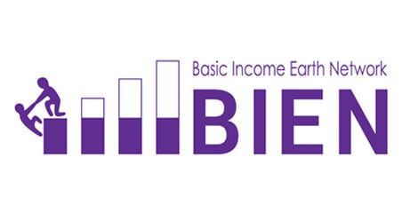
BIEN’s 2022 General Assembly
A meeting of the Basic Income Earth Network General Assembly will be held online, in connection with the 2022 BIEN Congress, on Wednesday 28th September 2022 at 13:00h British Summer Time (UTC+1).
This meeting will constitute the Annual General Meeting of the Charitable Incorporated Organisation The Basic Income Earth Network (BIEN)
The papers for the General Assembly will appear on the website at http://basicincome.org/general-assembly-2022
If you would like to have copies of the papers with you at the meeting, please print them out or have them available on your screen.
Agenda
13.00 | 1 | Opening of GA and welcome
13.05 | 2 | Confirmation by the Chair that a register of members present has been taken
13.07 | 3 | Approval of the agenda
13.10 | 4 | Approval of the minutes of the 2021 General Assembly
13.15 | 5 | Matters arising from the minutes not elsewhere on the agenda
13.25 | 6 | Treasurer’s report, annual report and accounts for 2021, and financial statement for the period 1st January to 30th June 2022.
13.30 | 7 | Appointment of auditor: Proposal that Tony Garrood should be reappointed as auditor.
13.35 | 8 | Elections to the Executive Committee: 1. Social media officer; 2. News editor; 3. BIEN hubs supervisor; 4. Volunteer Coordinator
13.50 | 9 | Report from the Chair and Vice-Chair
14.00 | 10 | Other Executive Committee reports
14.10 | 11 | Report from the Clarification of the Basic Income Definition working group established at the 2019 General Assembly
14.20 | 12 | Affiliation requests received: Chile, Bangladesh, Mission Possible 2030
14.30 | 13 | Venue for the 2024 congress
14.40 | 14 | Any other business (which should be notified to the Chair before the meeting begins)
14.50 | 15 | Close of meeting

The rules for running the General Assembly will be those found in BIEN’s constitution. Those rules likely to be relevant to the management of the General Assembly are as follows:
10 (2) Taking ordinary decisions by vote … any decision of the members of the CIO may be taken by means of a resolution at a general meeting. Such a resolution may be passed by a simple majority of votes cast at the meeting …
11 (3) (a) The charity trustees … must give at least 14 clear days notice of any general meeting to all of the members … (b) If it is agreed by not less than 90% of all members of the CIO, any resolution may be proposed and passed at the meeting even though the requirements of sub-clause (3) (a) of this clause have not been met. This sub-clause does not apply where a specified period of notice is strictly required.
11 (4) Chairing of general meetings. The person nominated as chair … shall, if present at the general meeting and willing to act, preside as chair of the meeting. Subject to that, the members of the CIO who are present at a general meeting shall elect a chair to preside at the meeting.
11 (5) Quorum at general meetings. No business may be transacted at any general meeting of the members of the CIO unless a quorum is present when the meeting starts. … the quorum for general meetings shall be the greater of 3% or three members. …

